Unveiling Market Insights Analyzing Spending Behavior

INTRODUCTION

- Overview

"Unveiling Market Insights Analyzing Spending Behavior" is a research initiative focused on comprehensively understanding consumer spending behavior within a specific market

- Purpose

  - Gain Deeper Understanding:

    - The primary purpose is to gain a comprehensive understanding of consumer spending behavior within a specific market. This understanding can help businesses, organizations, and policymakers make informed decisions.

  - Identify Trends:

    - You aim to identify spending patterns, trends, and factors that influence how consumers allocate their resources, helping businesses adapt their strategies accordingly.

  - Provide Valuable Insights:

    - Your project seeks to provide valuable insights that can inform marketing strategies, product development, pricing, and other aspects of businesses operating in the chosen market.

  - Aid Decision-Making:

    - Ultimately, your research serves the purpose of aiding decision-makers in making more informed choices, whether it's in the context of product development, advertising, or economic policies.

Problem Definition & Design Thinking

- Empathy Map

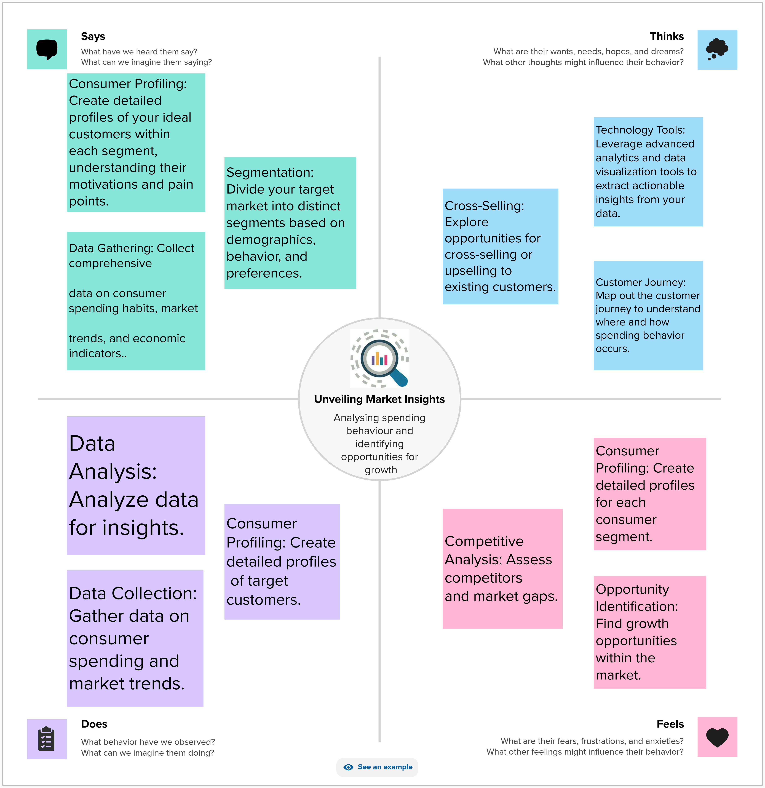

- deation & Brainstorming Map
RESULT

Sheet 1



Sheet 2



Sheet 3

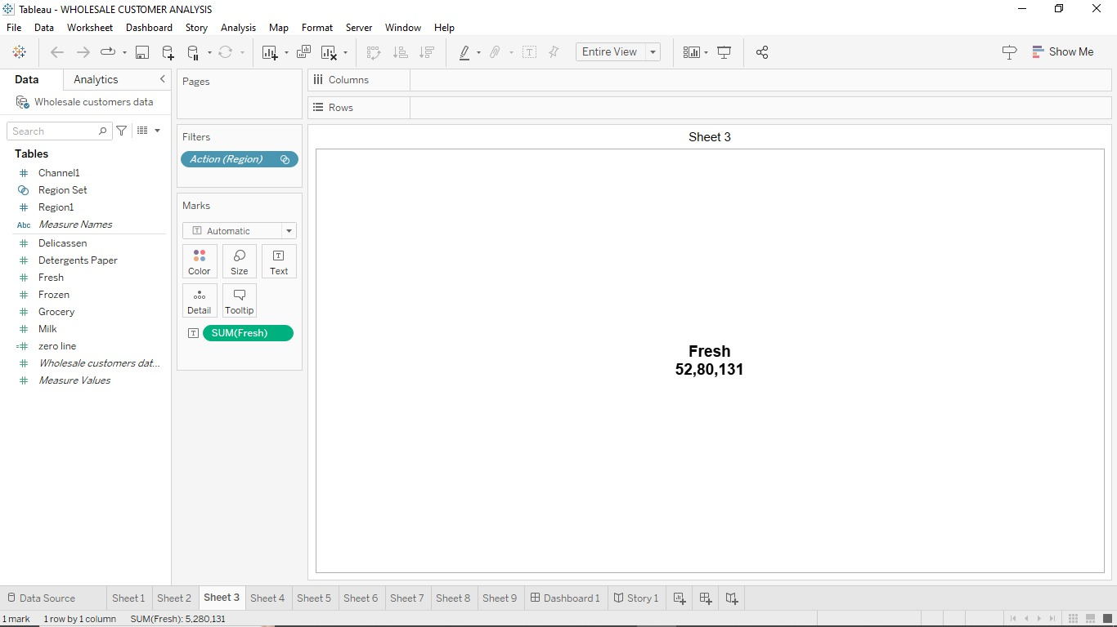

Sheet 4

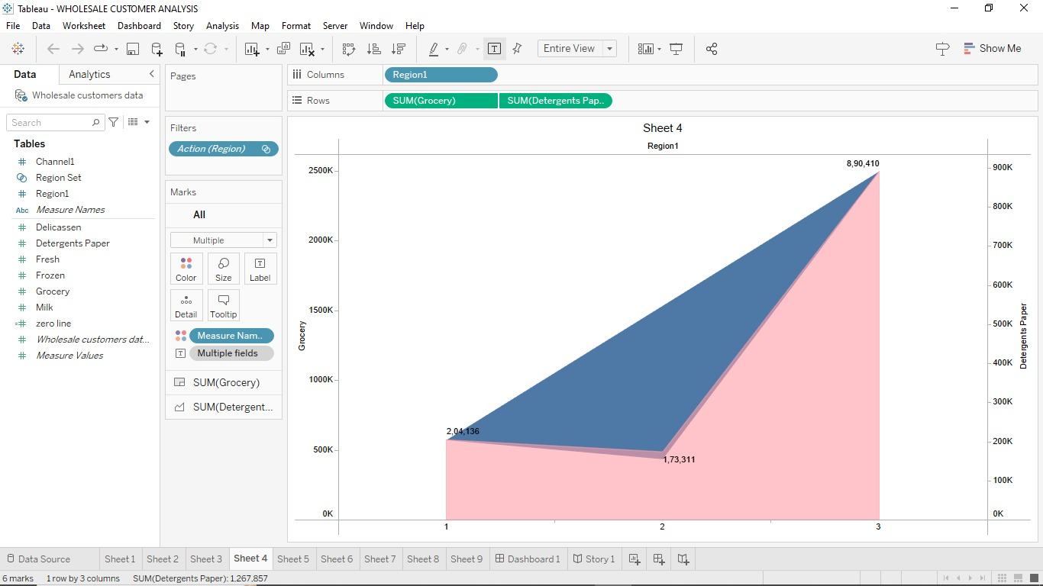

Sheet 5

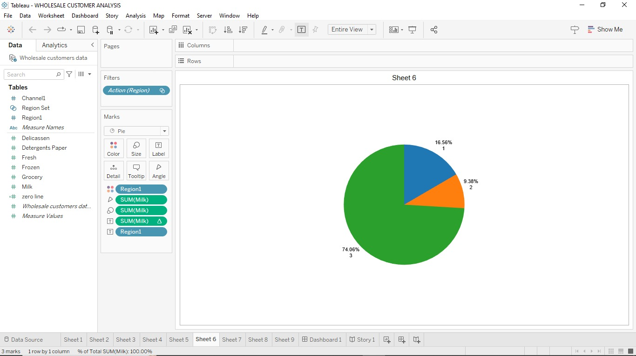

Sheet 6

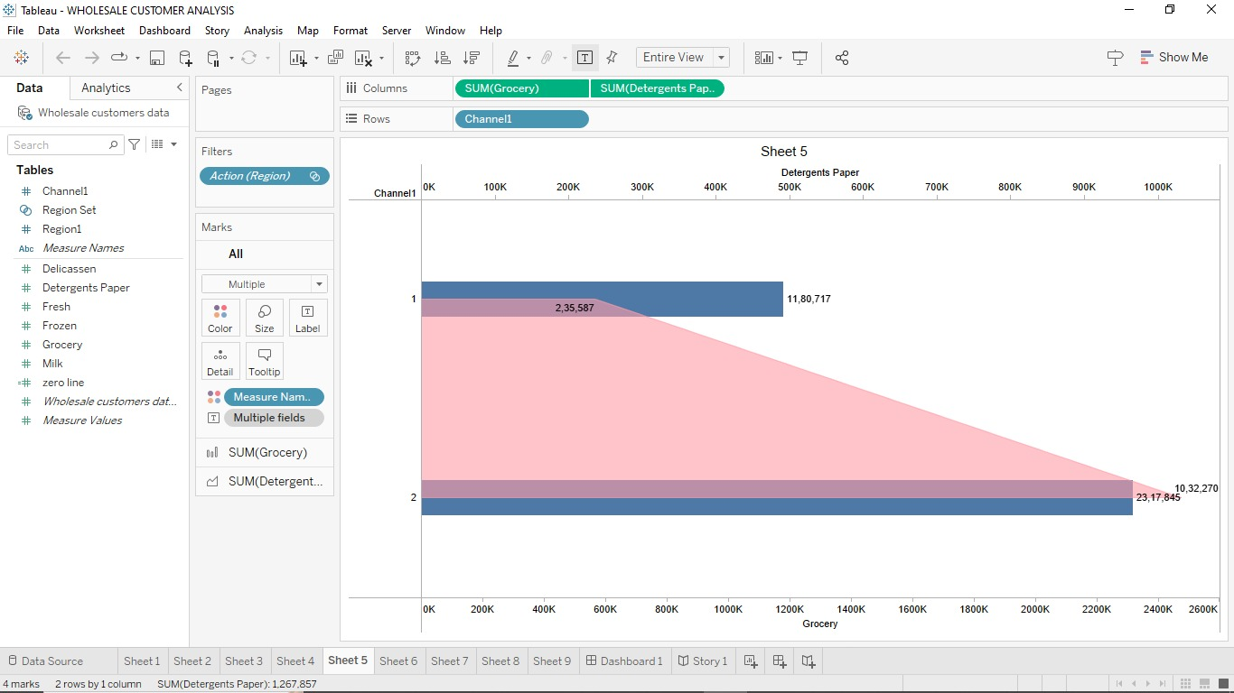

Sheet 7

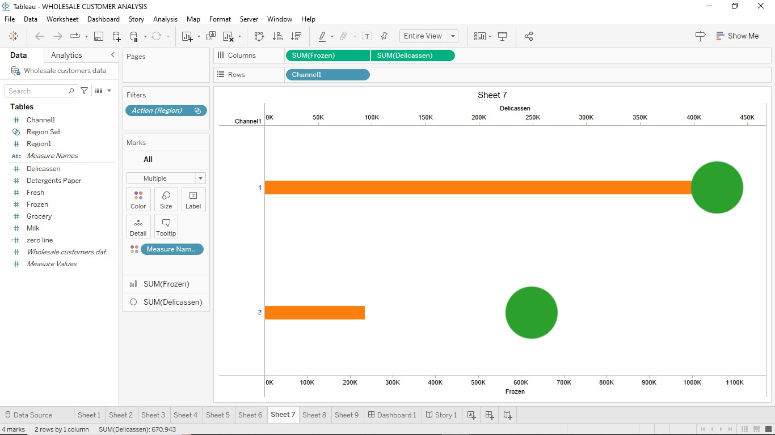

Sheet 8

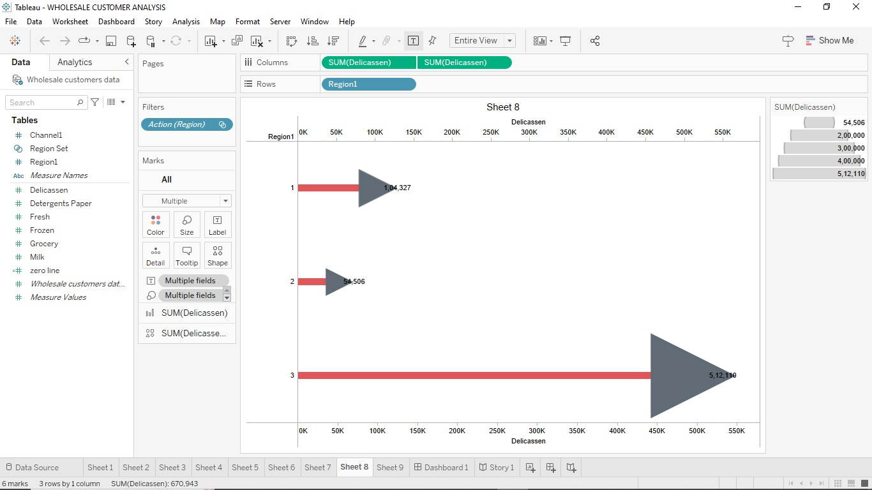

Sheet 9

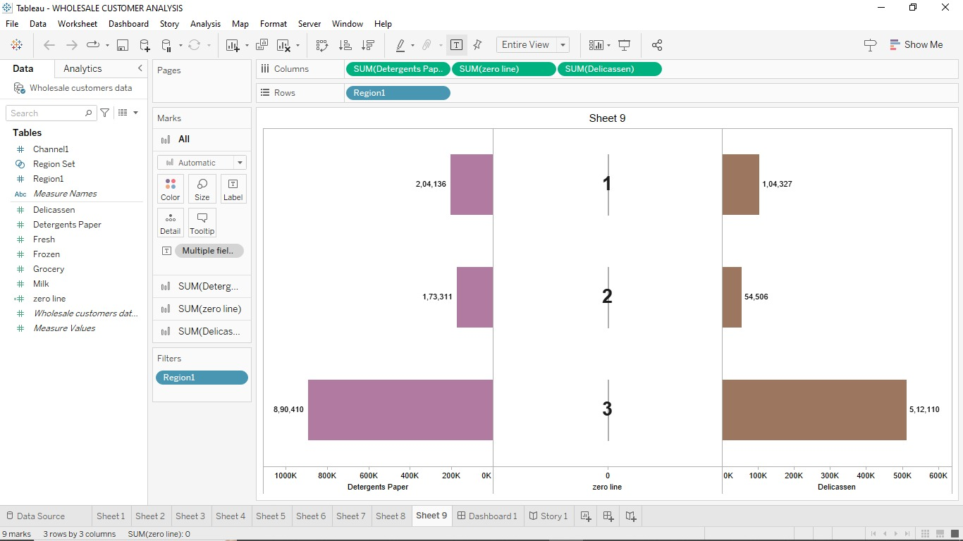

Dashboard
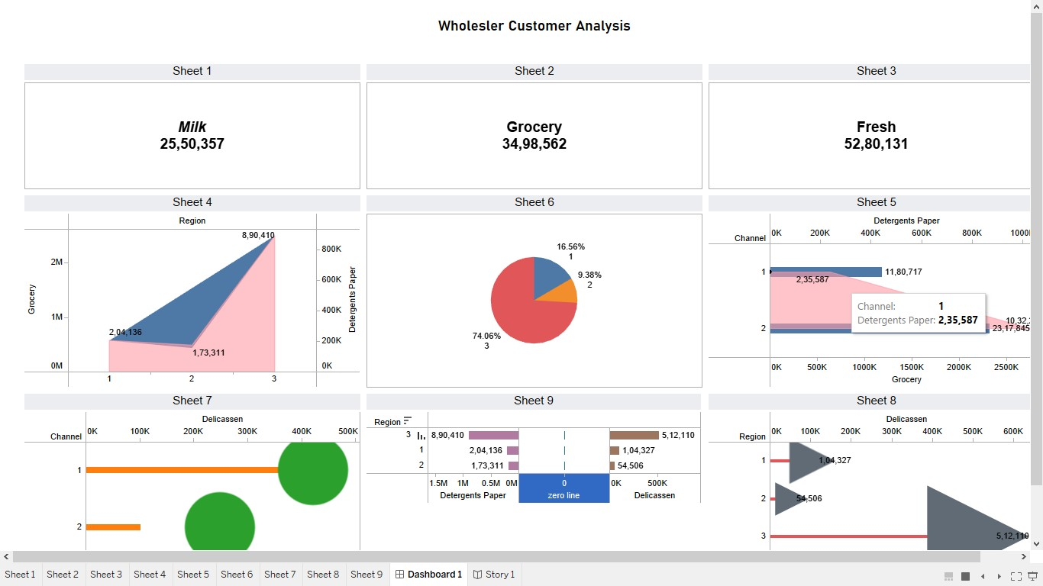

Story

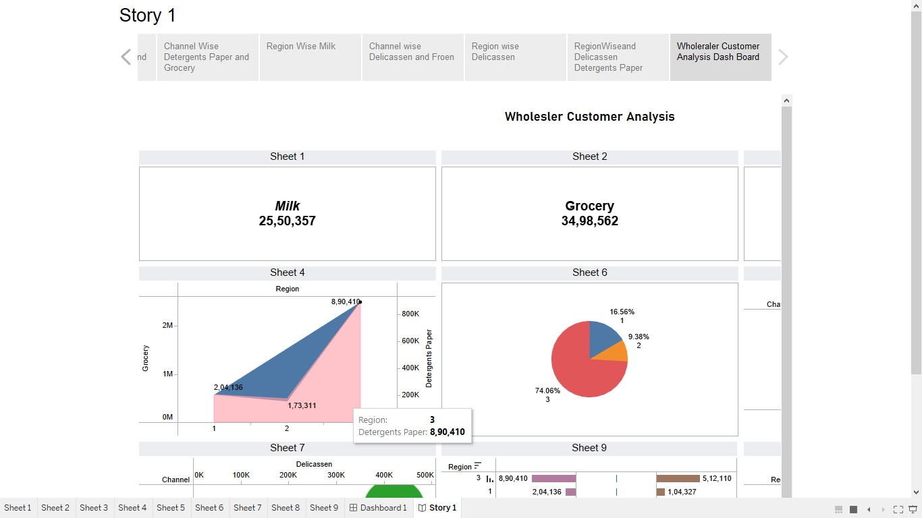

ADVANTAGES & DISADVANTAGES

- ADVANTAGES

  - Informed Decision-Making
  - Targeted Marketing
  - Competitive Edge
  - Risk Mitigation
  - Economic Policy Development

- DISADVANTAGES

  - Data Privacy Concerns
  - Cost and Resources
  - Interpretation
  - Changing Market Dynamics
  - Ethical Considerations

APPLICATIONS

"Unveiling Market Insights Analyzing Spending Behavior," have broad-ranging applications. They can empower businesses to refine their strategies, enhance consumer engagement, and boost profitability. Financial institutions can develop more tailored financial services, while policymakers can create consumer-centric economic policies. Market research firms can offer specialized services, non-profits can better target their outreach efforts, and advertisers and media companies can fine-tune their content. In retail and e-commerce, the insights can optimize operations, and academia can benefit from enriched studies in consumer behavior and economics, making your research invaluable in driving informed decisions across various sectors.

CONCLUSION

In conclusion, this project has undertaken the vital task of unraveling the intricacies of consumer spending behavior within a specific market. By conducting comprehensive research, we have uncovered valuable insights that can be leveraged by businesses, policymakers, and various sectors to make informed decisions. These findings offer the potential to drive competitive advantages, better customer engagement, and more relevant financial services. As the market continues to evolve, the significance of understanding consumer behavior remains paramount. This project serves as a foundational step toward achieving this understanding and its myriad practical applications. The pursuit of unraveling market insights and analyzing spending behavior is an ongoing journey, one that holds the promise of continuous innovation and adaptation to the ever-changing dynamics of consumer choices and preferences.

FUTURE SCOPE

- Advanced Data Analytics
- Cross-Market Comparisons
- Real-Time Data
- Behavioral Economics Integration
- Consumer Privacy and Ethics
- Sustainability and Social Responsibility
- Digital Transformation
- Public Health and Well-being
- Policy Adaptation
- Educational Initiatives

***************************************************************************************************************************************************

